**Augmentation None:**

Total images: 67

Correct predictions: 59

Accuracy: 88.06%

**Augmentation upscale:**

Total images: 67

Correct predictions: 58

Accuracy: 86.57%

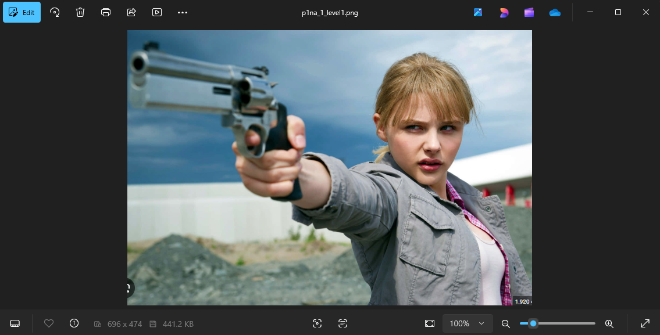

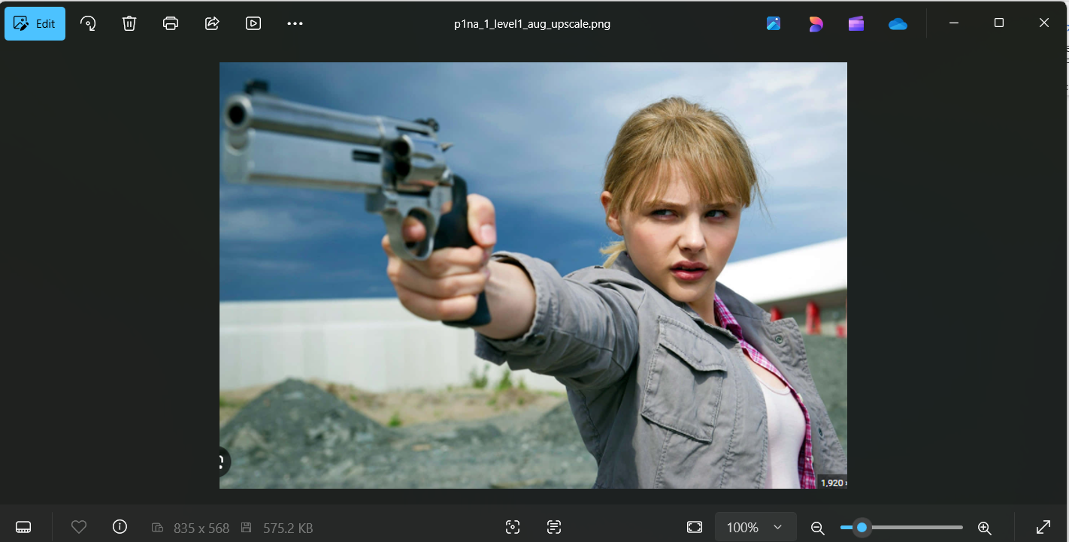

**Augmentation downscale:**

Total images: 68

Correct predictions: 58

Accuracy: 85.29%

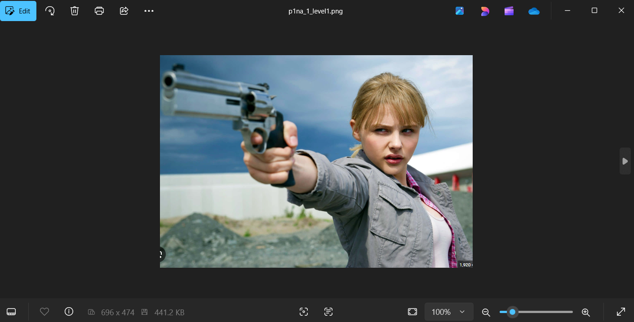

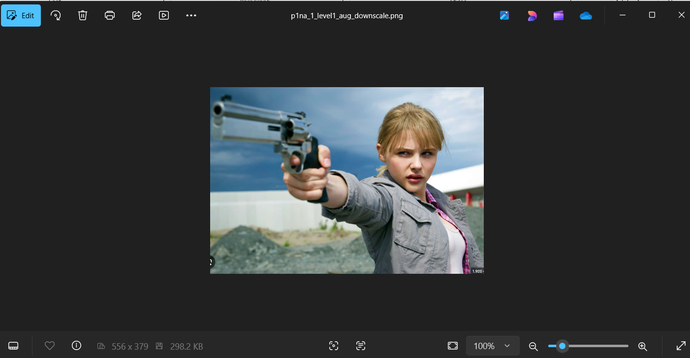

**Augmentation darken:**

Total images: 67

Correct predictions: 55

Accuracy: 82.09%



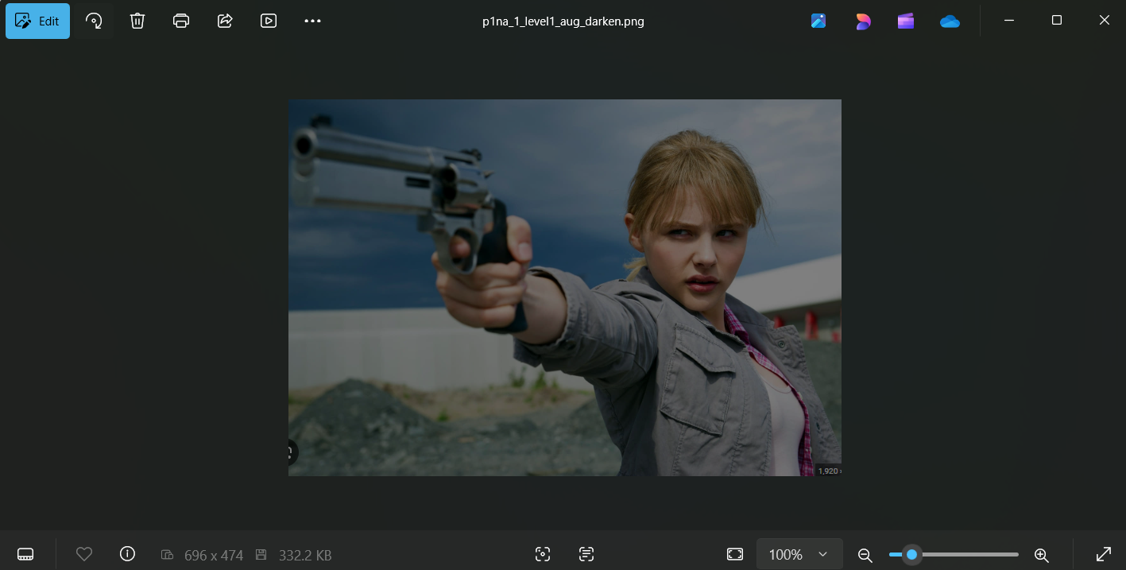

**Augmentation lighten:**

Total images: 67

Correct predictions: 56

Accuracy: 83.58%

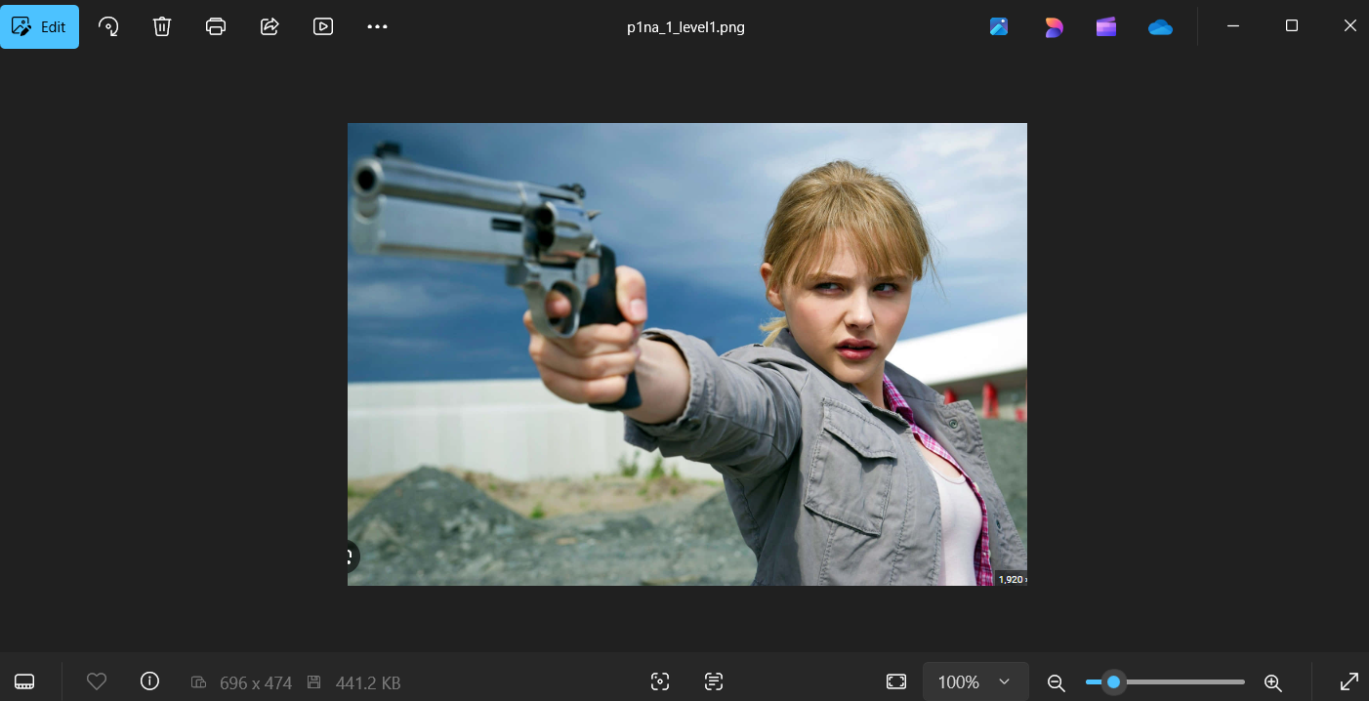

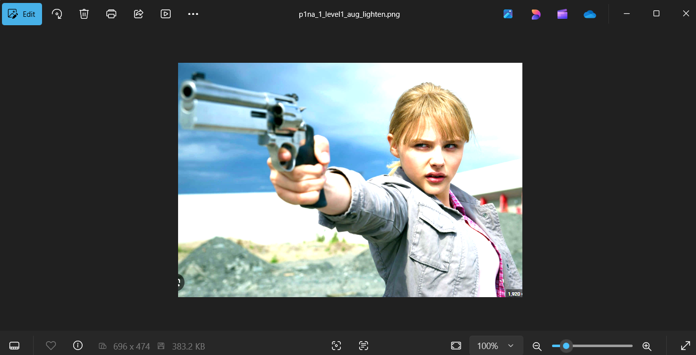

**Augmentation contrast_up:**

Total images: 67

Correct predictions: 55

Accuracy: 82.09%

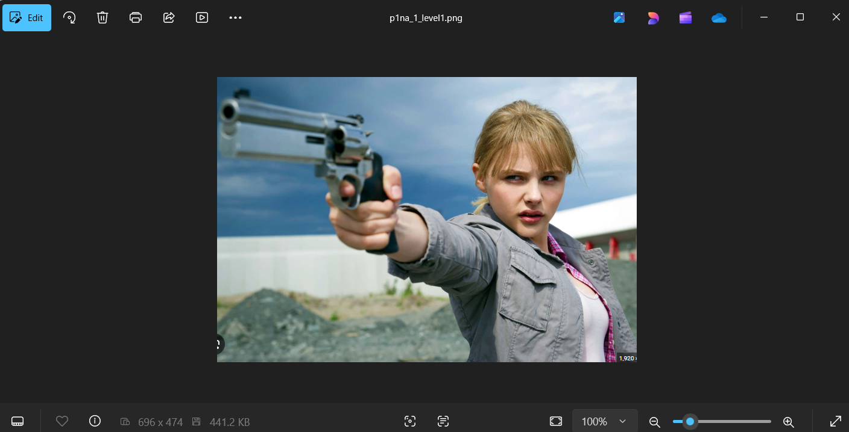

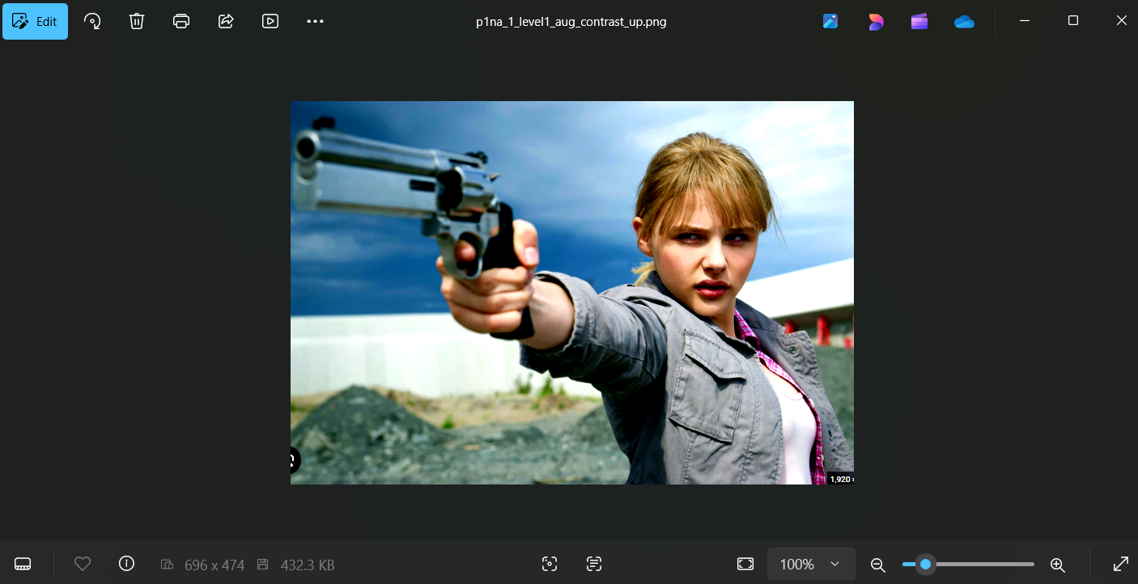

**Augmentation contrast_down:**

Total images: 68

Correct predictions: 58

Accuracy: 85.29%



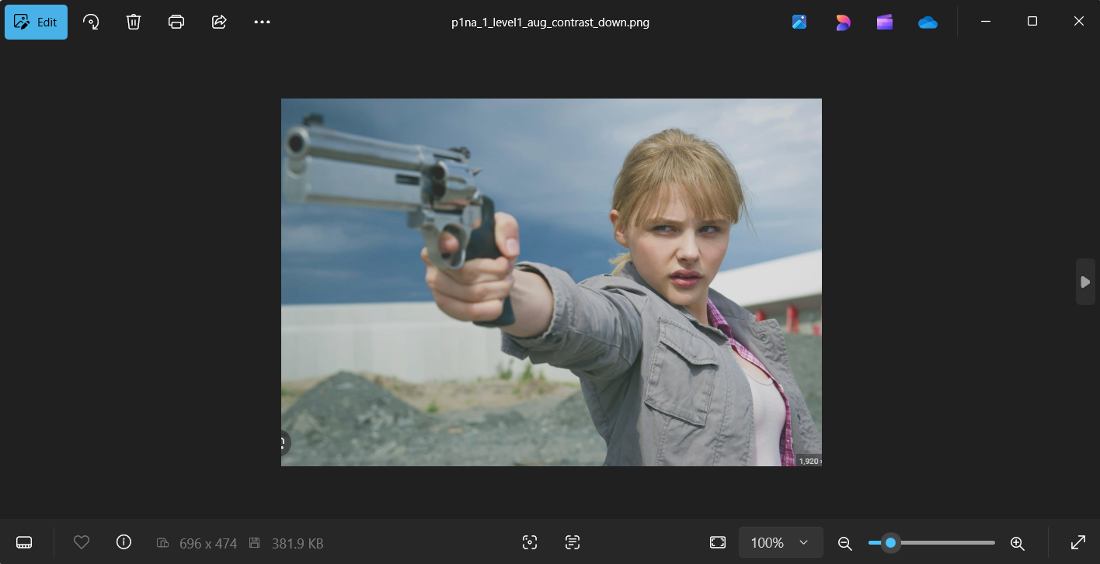

**Augmentation rotate15:**

Total images: 67

Correct predictions: 52

Accuracy: 77.61%



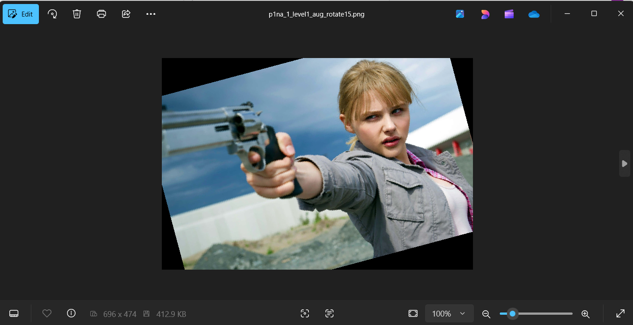

**Augmentation rotate-15:**

Total images: 66

Correct predictions: 43

Accuracy: 65.15%



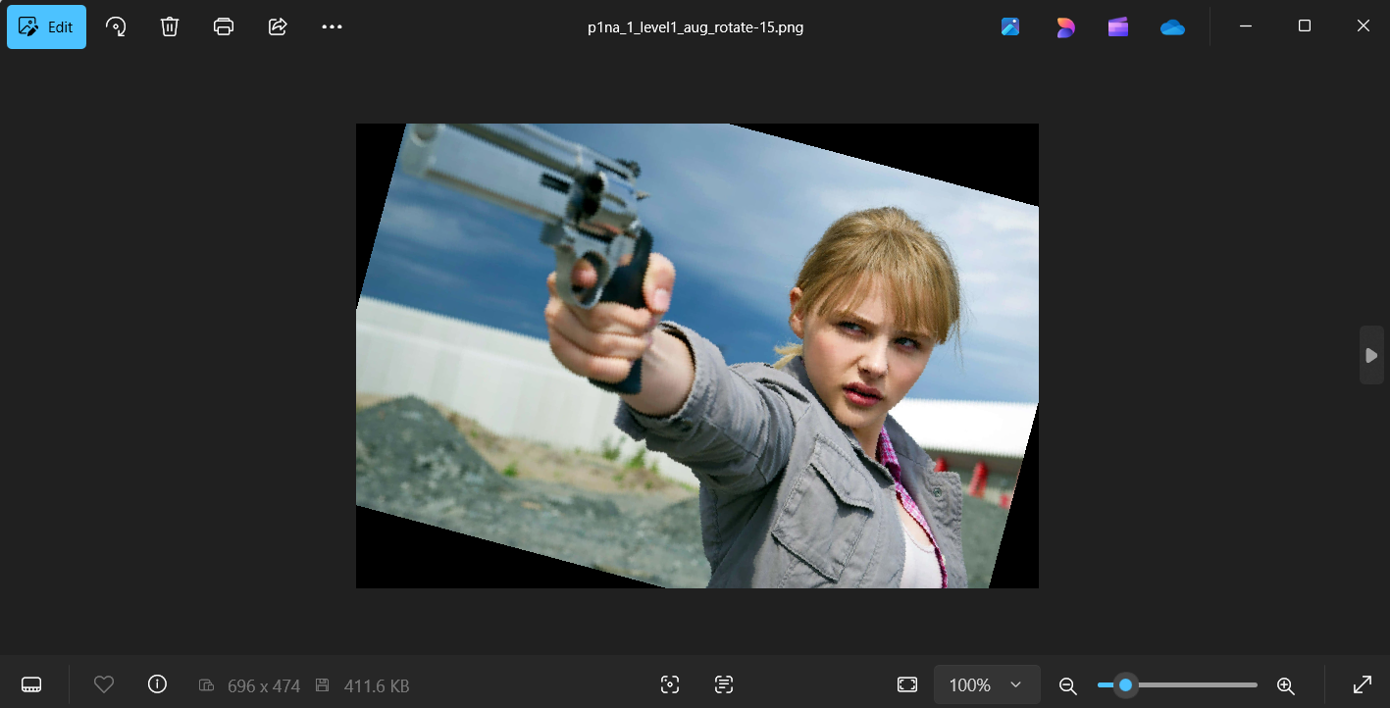

**Augmentation sharpen:**

Total images: 67

Correct predictions: 57

Accuracy: 85.07%



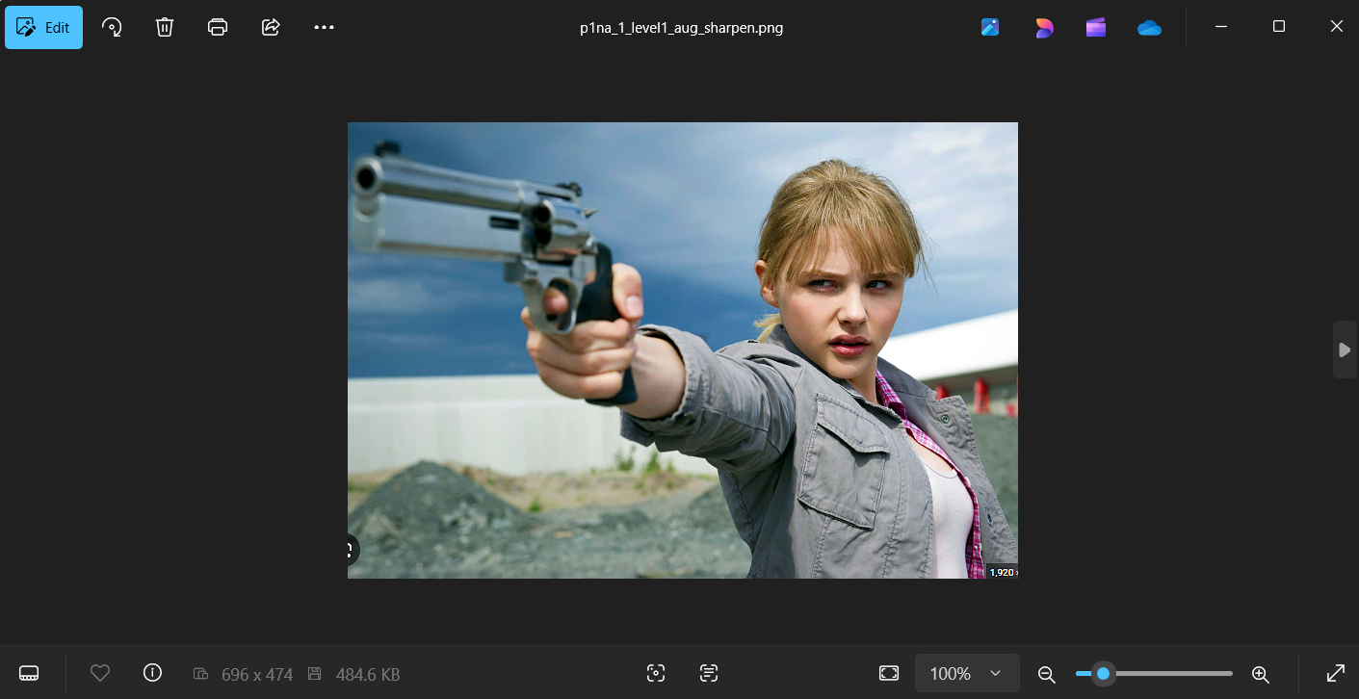

**Augmentation blur:**

Total images: 68

Correct predictions: 58

Accuracy: 85.29%



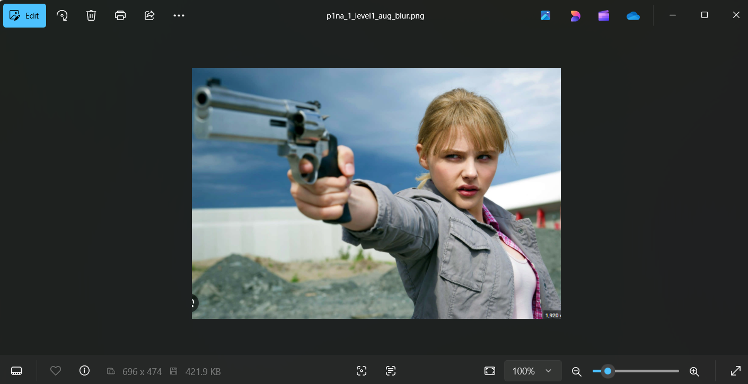

**Augmentation desaturate:**

Total images: 68

Correct predictions: 58

Accuracy: 85.29%



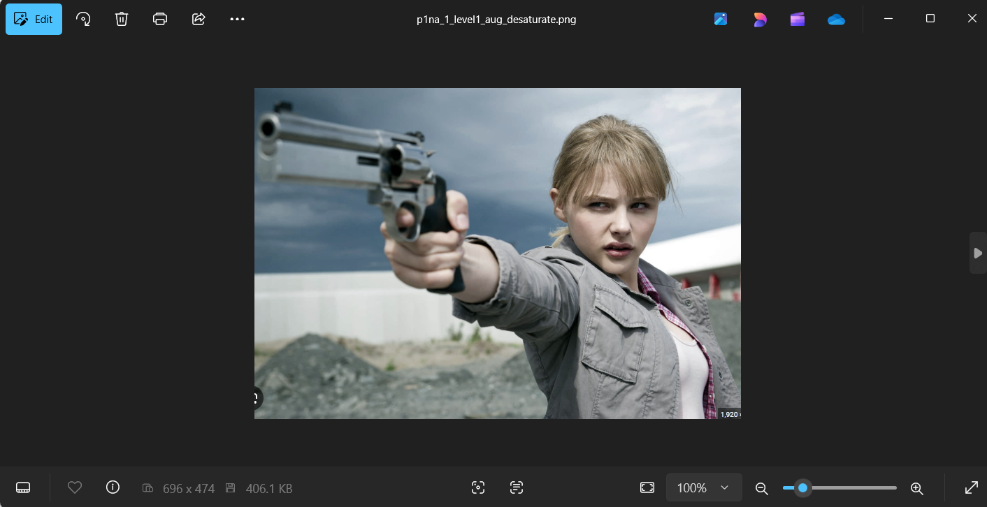

**Augmentation saturate:**

Total images: 68

Correct predictions: 59

Accuracy: 86.76%



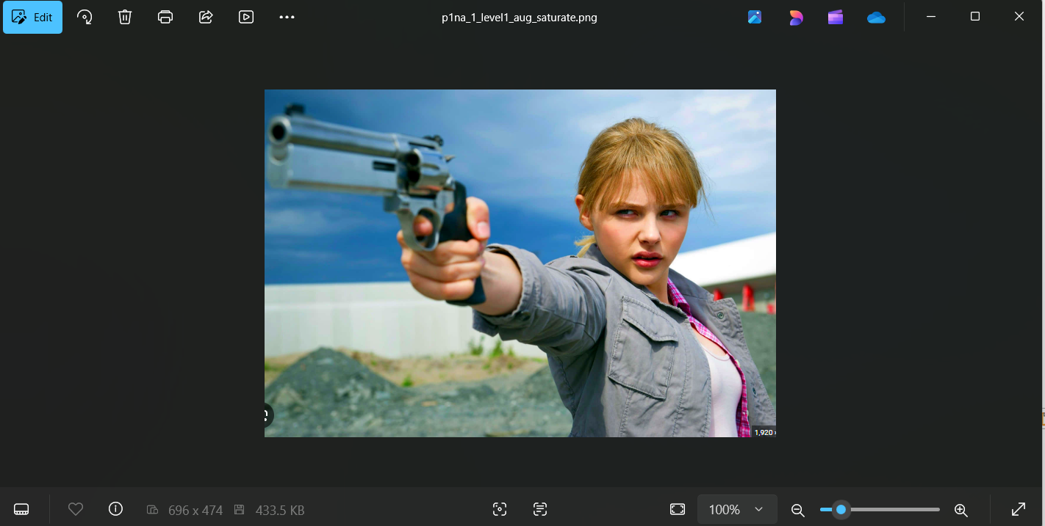

**Augmentation multiple:**

Total images: 67

Correct predictions: 51

Accuracy: 76.12%



